Strings, Bugs, and Compiler Warnings
Objective
Practice secure string handling and learn how compiler warnings catch vulnerabilities.

Basic C string functions
This program teaches basic C string functions:
- strcmp is used compare
- strcat is used to concatenate
- strcpy is used to copy
- strlen is used to find the length

Mini Labs: C String Functions
1: String Comparison (strcmp)
Task
- Write a program that asks the user for two strings.
- Use strcmp to compare them.
- Print whether they are equal or not.
Solution:
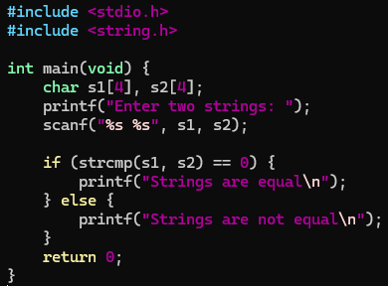

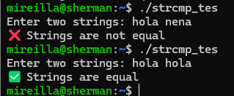

2: String Concatenation (strcat)
Task
- Read two strings.
- Join them using strcat.
- Print the result.

3: String Copy (strcpy)
Task
- Read one string into s1.
- Copy it into s2.
- Print both strings.

4: String Length (strlen)
Task
- Read a string.
- Use strlen to count characters.
- Print the result.

5: Combine Everything (Final Program)
Task
- Combine all four functions into one program:
  - Compare two strings.
  - If not equal, concatenate them.
  - Copy result into a third string.
  - Print lengths of all.
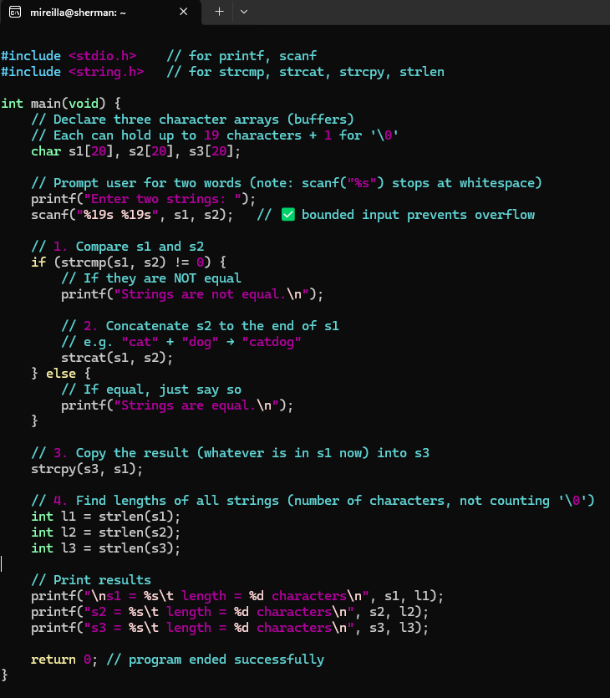
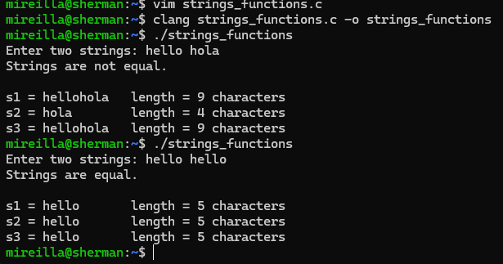

Safe alternatives
Modify the tasks above to use safe string functions:
Replace scanf("%s") with fgets. fgets reads full line safely, including spaces. So, it prevents buffer overflow + allows spaces.
Replace strcat with strncat. strncat concatenates with length limit. strncat prevents writing past buffer end when concatenating
Replace strcpy with strncpy, which copies with length limit. strncpy prevents overflow when copying.
s3[sizeof(s3)-1] = '\0'; ensures string is always null-terminated.

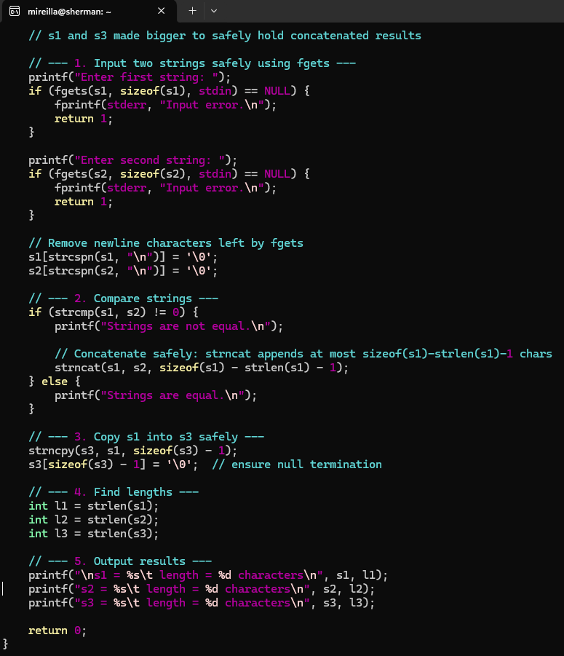
fgets reads full line safely, including spaces. So, it prevents buffer overflow + allows spaces.
strncat concatenates with length limit. strncat prevents writing past buffer end when concatenating
strncpy copies with length limit. strncpy prevents overflow when copying.
s3[sizeof(s3)-1] = '\0'; ensures string is always null-terminated

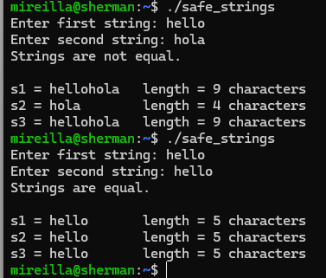

Compiler Warnings (-Wall -Wextra -Werror)
Many vulnerabilities start as “just warnings.” -Wall -Wextra are compiler flags for GCC/Clang. They do not change how the program runs, but they change how much the compiler warns you about possible problems. -Wall -Wextra makes the compiler act like a security assistant, catching unsafe coding before it ships. Good security practice: compile with warnings enabled, treat them as errors using -Werror during development.
-Wall enables a broad set of common warnings.
Examples:
- Using an uninitialised variable.
- Forgetting a return in a non-void function.
- Writing if (x = 5) instead of if (x == 5) (assignment instead of comparison).
- Declaring a variable and never using it.

-Wextra enables additional warnings that aren’t included in -Wall.
Examples:
- Unused parameters in functions.
- Signed/unsigned comparison (e.g., comparing int with size_t).
- Suspicious pointer arithmetic.
-Werror treats warnings as errors (forces you to fix them)

Example
This example shows that:
Uninitialised variables are dangerous. Using an uninitialised variable (x) leads to unpredictable results. In security terms, this could leak old stack memory, which might contain passwords, keys, or other secrets.
Assignment vs comparison mistakes (= vs ==).
if (z = 10) is legal C, but almost never what you want. This is a classic logic bug, the condition is always true. In security-critical code, such a mistake could cause authentication checks to always succeed (e.g., if (is_admin = 1), it means every user becomes admin).
Compilers do not save you unless you ask.
Without -Wall -Wextra, this compiles quietly.
With warnings enabled, the compiler catches both problems.
Here is the demo_warnings.c file.
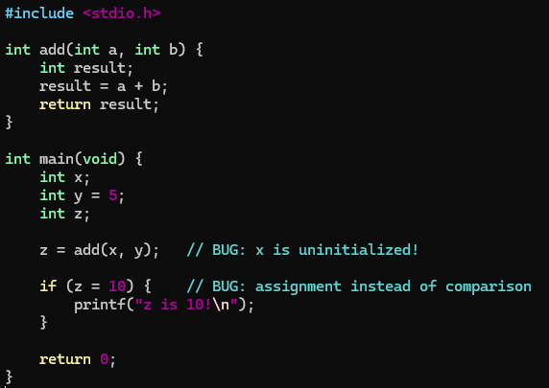
Example output 1:
The code below shows that when compiled using Clang, Clang enables some critical warnings by default, only the most obvious errors.
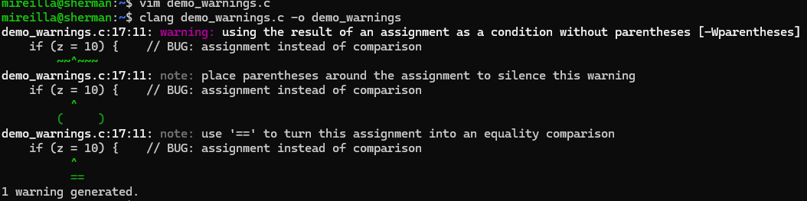
Example output 2:
Because if (z = 10) always assigns 10 to z, which is nonzero, so the condition is always true. GCC does not warn by default about assignment-in-if. Without -Wall -Wextra, dangerous bugs slip through.
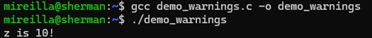
Example output 3: -Wall -Wextra are necessary in GCC to catch bugs that Clang might warn about automatically.
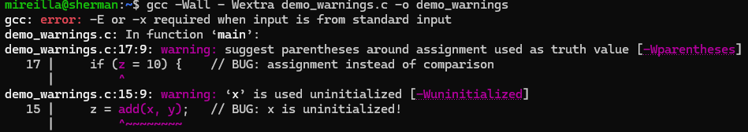
Example output 4:
When you use -Wall -Wextra, you activate a much larger set of diagnostic checks. That is why the same code using clang produced 2 warnings rather than the first 1 warning.
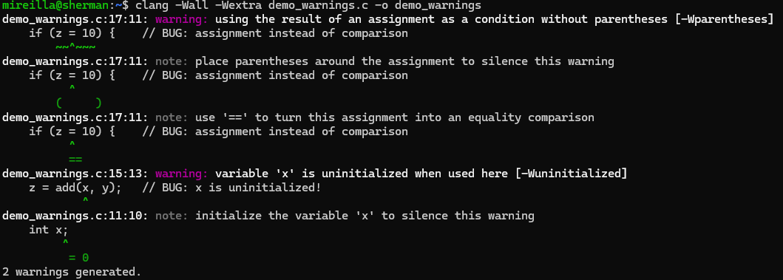

In conclusion, it is good practice to always compile with at least -Wall -Wextra.
These flags do not fix bugs, but they often catch them early.
In security-sensitive code, ignoring warnings can lead to exploitable flaws.
-Werror treats warnings as errors (forces you to fix them).

